Department of Veterans Affairs

Data Stewardship Guidance

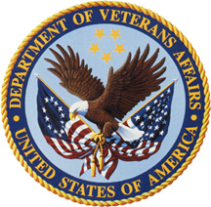

February 14, 2017

DRAFT

Version 2.0

**Document Change Record**

|  |  |  |  |
| --- | --- | --- | --- |
| Date | Version Number | Owner | Description |
| 04/01/2016 | 1.0 | Office of Enterprise Integration | VAIQ 7689793 |
| 04/07/2016 | 1.0 | Office of Enterprise Integration | First Draft Submitted to OPP Leadership |
| 04/14/2016 | 1.1 | Office of Enterprise Integration | Stakeholder edits incorporated |
| 510/12/16 | 1.1 | Data Governance Council | Approved |
| 01/26/2017 | 2.0 | DGC Stakeholders | Updated to reflect common and shared information data stewardship requirements |
| 01/14/2017 | 2.0 | DGC Members | Guide forwarded to DGc members for review and edits |
| 02/14/2017 | 2.0 | DGC Members | Approved |
| 05/19/2017 | 2.0 | VAIQ 7689793- | Approved by COS |

Table of Contents

1.0 Introduction 5

2.0 Business Data Stewards 6

2.1 Roles and Responsibilities 6

2.2: Common Information Data Steward Reporting 7

2.3 Shared Information Data Steward Reporting 7

3.0 Technical Data Stewards 8

3.1 Roles and Responsibilities 8

4.0 Glossary 9

Appendix A: RACI 11

Appendix B: Questions and Answers 12

Appendix C: Acronyms 15

# 1.0 Introduction

The VA Data Governance Council (DGC) implements the requirements of VA Directive 6518, Enterprise Information Management (EIM) for the management of VA data by creating and maintaining policy, processes and standards to ensure that VA common data are managed to provide the most integrated, efficient and effective service possible to VA customers and internal business operations. VA Data is divided into three Segments: Common, Shared and Organziational Specific. Figure 1 detials the data stewardship requirements.

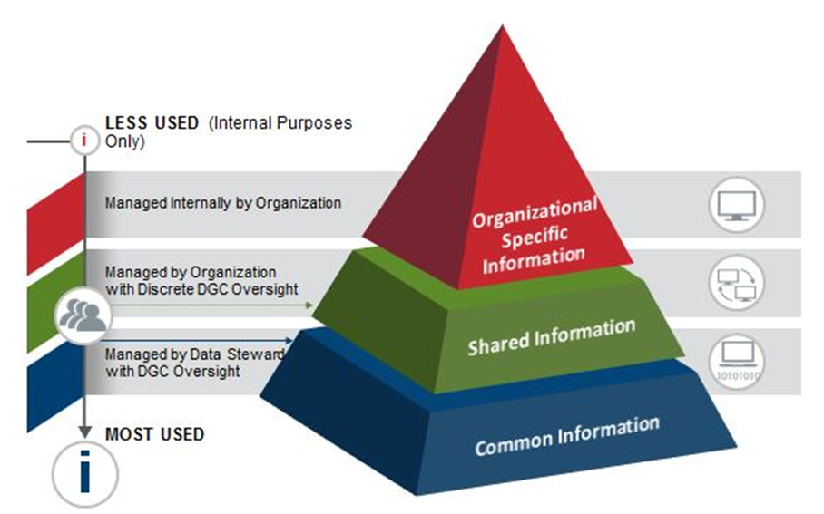

Fifure 1- VA Data Segments and Stewardship

The DGC process for managing VA common data begins with the identification and designation of a common information Subject Area. The Common Information Data Steward that will be responsible for providing authoritative and accountable decisions regarding the definition, interpretation and use of this data. The Steward is responsible for the data integrity and quality on behalf of all of the Department’s stakeholders and users of that data.

The DGC process for managing VA shared and organizational specific data begins with the identification and designation of the data elements in these categories. Shared data is managed by an administration or staff office data steward who is accountable for the standards of the data and its governance.  Business rules and standards for “shared" information shall be defined and managed  by the business line with input from the data users, with the added responsibility of making the data available and understandable for the consuming organizations.  Data issues that cannot be resolved between the Data Steward and data users can be escalated to the DGC for resolution.

The organizational specific data is managed by an administration or staff office data steward who is accountable for the standards of the data and its governance.  In this case, each organization can establish the most appropriate internal infrastructure to manage it. However, for each data element within the organizational specific subject area a data steward or point of contact needs to be listed in the VEAR.

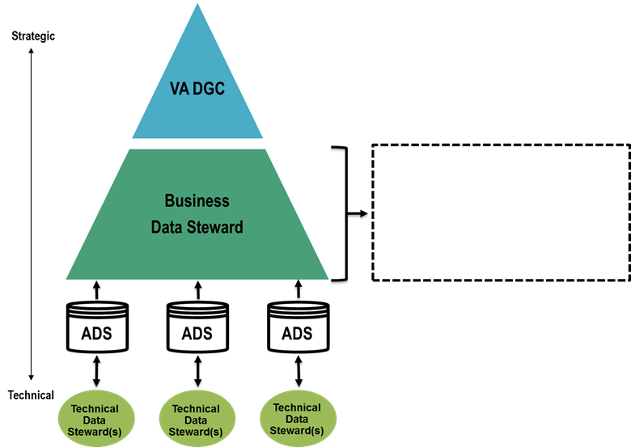

Subject Area

Stakeholders

Figure 1: Data Steward Network

This document outlines the roles and responsibilities of the Common and Shared Information Business and Technical Data Stewards. The document includes a series of appendixes to provide a better understanding of data stewardship in VA. For quick reference, Appendix A provides the Responsible, Accountable, Consulted, and Informed (RACI) Matrix.

# 2.0 Business Data Stewards

### The Data Steward is a business owner and/or recognized subject matter expert assigned accountability for the data specifications and data quality of the Subject Area. Business Data Stewards are experts in the way data is used in the performance of VA’s mission.

## 2.1 Roles and Responsibilities

* Establish policy, processes, and standards for the management of assigned Subject Area to include:
  1. Defining and documenting business processes and rules, data standards, data architecture, data quality attributes/measures, metrics, decision rights, and metadata management.
  2. Ensuring department-wide stakeholders are engaged in decision making.
  3. Stewards serve as integrators for accomplishing data governance tasks.
  4. Business processes and rules, data standards, data architecture, data quality attributes/measures, decision rights, Authoritative Data Source(s) designation, and metadata shall be formally documented.
  5. Ensuring their respective information subject Area has published conceptual and logical data models.
  6. Certifying that their respective information subject area complies with data quality standards.
  7. Guiding, approving, and communicating data management strategies
* Propose Authoritative Data Source(s) (ADS) for approval by the DGC.
* Ensure compliance with Open Data and Open Government guidelines, and provide all information deemed appropriate to the Department Open Data Point of Contacts.
* Ensure adherence to VA official guidance and policies, VA Information Privacy/Security policies and standards as well as Federal laws and regulation and publications.
* Ensures that data is shared and available for cross business line coordination and data analytics and serve as the resolution officer for a data issue resolution process including the escalation of issues to the DGC that cannot be resolved by the Business Data Steward.
* Coordinate as needed with process owners to align business processes and system business owners and maintainers to align system-specific data assets with requirements.
* Work with system business owners and maintainers to implement necessary controls (predictive, detective, and corrective) needed to ensure the quality of the data.
* Publish data quality assessment of their data to provide transparency for users.
* Collaborate with system business owners and maintainers to ensure that they map data assets to the enterprise logical model as it is built out and to industry standards as needed, and publish the mappings so that they are accessible to users.

## 2.2: Common Information Data Steward Reporting

The DGC will designates a Business Data Steward for each Common Information Subject Area and identify the organization to which the Data Steward is assigned.

* The Common Information Data Steward reports the status of the Subject Area at the monthly DGC meetings.
* Participated in the Common Information Data Stewards meetings held monthly to coordinate DGC follow up actions
* Submits DGC reporting templates and/or slides to the DGC Secretariat one week or seven (7) days prior the next scheduled DGC

## 2.3 Shared Information Data Steward Reporting

Shared Information Data Stewards are identified by the organization that generates and manages the data element and are presented to the DGC for endorsement. Upon DGC review, the information is entered in the VEAR. The Shared Information Data Stewards Business Data Steward that will be responsible for providing authoritative and accountable decisions regarding the definition, interpretation and use of this data. Thereby, they have the same responsibilities than the Common Information Data Stewards with the following reporting exceptions:

* Participated in the DGC meetings but is not required to provide regular reports to the DGC.
* Provide reports of the subject area data management activities at the DGC Co-Chairs Shared Information Data Stewards meetings as requirested.
* Provide specific reports of the subject area data management activities to the DGC when prompted by the by the DGC Secretariat on behalf of the DGC members.

# 3.0 Technical Data Stewards

The Technical Data Stewards have direct operational level responsibility for information management related to the capture, maintenance, dissemination and use of data and data administration activities. Technical Data Stewards are responsible for the implementation of data access, security, integrity, and documentation of data contained in VA databases. The Technical Data Steward will generally be the person who performs the day to day operation and maintenance of the ADS.

## 3.1 Roles and Responsibilities

* Advise the Business Data Steward in the development of policy and processes for the information Subject Area.
* Identify and coordinate IT support and report to the Business Data Steward as needed.
* Implement the policy and processes established by the Business Data Steward.
* Ensure adherence to VA official guidance and policies, VA Information Privacy/Security policies and standards as well as Federal laws and regulation and publications.

# 4.0 Glossary

* **Authoritative Data Source (ADS**)**:** A source of data or information designated and recognized as official that is trusted, timely, secure and used within VA’s information environment in support of VA business processes. Administrations and Staff Offices designate these sources within domains for which they are the stewards. The Office of Information and Technology develops and maintains technical solutions (e.g. services) that use these sources. (Source: VA Directive 6518, Enterprise Information Management)
* **Business Data Steward:** A business leader and recognized subject matter expert assigned accountability for the data specifications and data quality of specifically assigned business entities, subject areas or databases. Business Data Stewards are identified by the Line of Business and/or Program office and are experts in the way data is used in the performance of VA’s mission. They are responsible for defining data requirements and determining access needs and appropriate usage for data. (Source: VHA OIA Data Quality Program adapted from DAMA Dictionary of Data Management, 2nd Edition 2011)
* **Common Information / Common Data:** The VA shall identify and designate as "common" all information that is defined by, created/captured by and shared across multiple Administrations, staff offices, or other organizational entities across the VA Enterprise to conduct business including all data from the corporate functions I.e., e.g., OALC,OM, OIT, HRA).
* **Data Governance Council (DGC):** The DGC, comprised of executive leaders from VA Administrations and Staff Offices, was created to establish and implement Data Governance policy and enterprise practice to include use of authoritative data, data architecture and other data management artifacts. The DGC provides a leadership sponsored opportunity to implement an open and transparent governance process. As a council of the VA organizations, the DGC also provides an avenue to communicate and foster collaboration. (Source: Data Stewardship Roles and Responsibilities, 2016 Adapted from DAMA Dictionary of Data Management, 2nd Edition 2011)
* **Enterprise Information Management (EIM) Directive:** Establishes Enterprise Information Management (EIM) policy for the US Department of Veterans Affairs. The EIM directive defines the objectives, establishes overarching principles and policy, assigns responsibilities, and delegates authority for the management and use of VA’s information assets. (Source: VA Enterprise Information Management Directive, 2014)
* **Information Subject Area**: Business level classifications of VA data. They are an organizing mechanism to broadly describe and encompass key VA business concepts. They are used to coordinate the work of data stewards, subject-matter experts and those responsible for establishing data-related policy and to structure and organize business rules, process flows and information models. They provide a consistent method of cataloging the data contained within a wide spectrum of systems and facilitate efficient and authoritative decision-making about data. (Source: VHA OIA Data Quality Program)
* **Organization Specific Data:** The VA shall identify and designate as “organization specific" all information that is defined, created by one Administration or staff office for the use of that Administration or Staff Office only.
* **Shared Data:** The VA shall identify and designate as “shared" all information that is defined, created by one Administration or staff office and shared across multiple Administrations, staff offices, or other organizational entities.
* **Stakeholder:** Individuals or groups with an interest in the success of an organization in delivering intended results and maintaining the viability of the organization's products and services. Stakeholders influence programs, products, and services and are influenced by the end result of a program or a project. They include both technical dependencies as well as business owners. (VA OIT Master Glossary).
* **Technical Data Steward:** Technical Data Stewards have direct operational level responsibility for information management related to the capture, maintenance, dissemination and use of data and data administration activities.  Technical Data Stewards are responsible for the implementation of data access, security, integrity and documentation of data contained in VA databases.

Can also be called Data Custodian. (Source: VA OIA Data Quality Program)

Note: The complete Data Management Glossary of commonly used terms and their definitions can be found at: <http://vaww.ea.oit.va.gov/va-ea-repositories/>

# Appendix A: Responsible, Accountable, Consulted, and Informed (RACI) Matrix

The DGC RACI can be found at this link: <https://www.vapulse.net/docs/DOC-71116>



# Appendix B: Questions and Answers

1. **What Federal Guidance supports VA Data Stewardship program?**

There are multiple documents that provide guidance on the data stewardship program requirements. Some of these documents are:

* 1. Federal Data Maturity Model
  2. Data Resource Management Guide
  3. GAO publication GAO/GGD-10.1.20, The Results Act–An Evaluator’s Guide to Assessing Agency APPs
  4. GAO/GGD-99-139, Performance Plans–Selected Approaches for Verification and Validation of Agency Performance Information
  5. OMB M-13-13, Open Data Policy
  6. VA Directive 6518, Enterprise Information Management (EIM) Policy

1. **What are the goals of a data stewardship program in VA?**

The Enterprise Data Stewardship Programing VA is intended to provide clean, accurate and consistent data that meets the business need, within an organization and across VA.

1. **What are the objectives of VA’s data stewardship program?**

Some specific objectives of the data stewardship program include the following:

* Ensuring that data stewards are recognized and integrated into the data governance hierarchy.
* Empowering data stewards by creating guidance on the different data management functions.
* Providing training and tools so the data stewards can fulfill their roles with the necessary resources to do it.
* Establishing, managing and monitoring the use authoritative data sources and their data quality to decrease costs and increase efficiencies.
* Providing transparency into the state of the data and ensuring that the ADS data quality issues are addressed and communicated in an effective, coordinated manner and will be efficiently escalated if there are cross-organization impacts or agreement can’t be reached at the data steward level.
* Identifying gaps for the management of data in VA to serve as an input to Planning and Investment processes. Gaps could include ADS capabilities and usage, or relate to quality, availability, security, etc.
* Ensuring that data analytics including data users:
  + have sufficient information to understand the data they need
  + have transparency into its data quality and any outstanding issues.
  + know who to call to get the answers that they need to do their jobs.

1. **What is the difference between data governance and a data stewardship?**

Data governance refers to the hierarchy for governing all VA data. A Data Stewardship Program defined accountability and responsibility for specific types of data, and leverages the data governance hierarchy to provide support and escalation functions. Data governance and stewardship provide organizations with the methodology and Tools for understanding VA’s data assets, relationships between data elements, and metadata definitions while improving data quality and ultimately increasing overall confidence and utilization of the data generated.

1. **How do organizations select a data steward?**

Each organization selects their data steward using their own criteria. Some of the most common characteristics of data stewards are:

* **Subject-matter expertise-** data stewards should be familiar with the business processes and the data within their assigned subject area. Most of the time the identified data stewards are already doing aspects of stewardship over the data they are assigned.
* **Excellent Communicator**: Data stewards facilitate communication regarding business process changes that may affect downstream systems or analytics relating to specific data elements. The ability to communicate well with individuals and groups, both in writing and verbally—and with both business and technical colleagues—is essential in conducting good data stewardship. Data Stewards work with a variety of roles and levels in both business and OIT and across administration boundaries. They also have the ability to understand, define, and document process as it relates to the data in their subject area.
* **Problem Solving/ Collaborator /Negotiator/Facilitator:** The ability to understand the root cause of data issues requires an understanding of the associated problems. Being able to think through the issues and devise a solution is a key asset for a data steward. Data Stewards have the ability to successfully facilitate consensus among the different Subject Area Stakeholders during meetings, reviews, and working sessions. This is accomplished by working with the subject area stakeholders to identify solutions to all data problems and concerns. This is accomplished because a data steward is an expert in acquiring and maintaining social capital by managing and maintaining relationships with numerous data stakeholders across VA. They leverage this relationship to identify solutions and make improvements to their subject areas.

1. **Who is the Technical Data Steward?**

The Technical data steward is a role, not a distinct job code. Technical Data Stewards are business people that manage the ADS (system) operations and maintenance. They have detailed knowledge of the data in the system they manage and have the tactical responsibilities for the data including: the capture, maintenance, dissemination and use of data and data administration activities. Technical Data Stewards are responsible for the implementation of data access, security, integrity, physical modeling, and documentation of data contained in VA databases. The Technical Data Steward will generally be the person who performs the day to day operation and maintenance of the ADS.

1. **Is there an onboarding process for data stewards?**

The DGC Secretariat manages and coordinates the onboarding activities for new data stewards. Upon appointment, the DGC Secretariat will:

* Provide an overview of the DGC and VA Data Governance Activities
* Provide access to the available data management functions guides
* Introduce the data steward to the available resources including other data stewards, DGC advisors and workgroups

1. **How the DGC supports the data steward?**

The DGC works with the data steward organization and other organizations in VA to provide the steward the resources needed successfully manage the data within the subject area. Resources could include any of the following:

* Identification and escalation of gaps including background information such as relevant policies and resources
* Highlighting the Business and OIT Budge priorities within the subject area
* Providing guidance to achieve the successful execution of data management activities within the subject areas
* Creating and disseminating training opportunities
* Building a culture of collaboration and connecting data stewards with other data stewards and DGC representatives

1. **What does support OIT provide to the Data Steward?**

OIT provides support to the data steward in the implementation of the subject area’s data management activities as follows:

* Assistance in understanding the data ecosystem.
* Identifying ADS migration requirements, creating migration plans and implementing those plans and prioritizing these requirements during the funding cycle
* Leveraging the subject area’s data architecture and rules during the systems planning, development and maintenance
* Providing tools and resources for the effective implementation of data management functions
* Data modeling and mapping resources

# Appendix C: Acronyms

| **Acronyms** | **Term** |
| --- | --- |
| ADS | Authoritative Data Source |
| DGC | Data Governance Council |
| EIM | Enterprise Information Management |
| GAO | Government Accountability Office |
| IT | Information Technology |
| OIT | Office of Information Technology |
| OMB | Office of Management and Budget |
| OPP | Office of Policy and Planning |
| RACI | Responsible, Accountable, Consulted, and Informed (RACI) Matrix |
| VA | Department of Veterans Affairs |
| VHA | Veterans Health Administration |